Making a complaint

I am feeling sad/unhappy/angry.

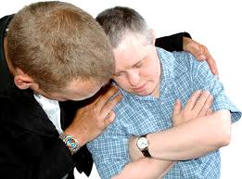

I should tell someone I trust.

They will help me to make a complaint.

Jamie and Becky will find out why I am sad.

Jamie and Becky might want to talk to me.

Jamie and Becky will explain what they have done to help me.

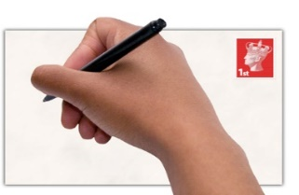
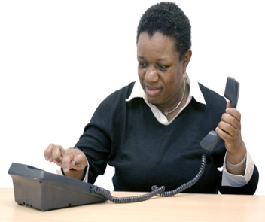
If I am still sad, the person I trust can help me contact my local council:

Bristol  Complaints Team  Room G27, City Hall  Freepost BS 4341  PO Box 595  Bristol  BS99 2BR  Tel: 0117 922 2723  Email: faircomment@bristol.gov.uk  Web: www.bristol.gov.uk/adultcare | South Glos  Call in at a Council One Stop Shop at Kingswood, Yate or Thornbury.  Tel: 01454 865924  Email: cchfeedback@southglos.gov.uk  Web: www.southglos.gov.uk
Bath & North East Somerset

Complaints Team - Bath and North East Somerset
Freepost SWB10433
Bath
BA1 1BF

Tel: 01225 477931

Email: complaints_cypandadults@bathnes.gov.uk

Web: www.bathnes.gov.uk

You can also contact:

Care Quality Commission
National Correspondence
City Gate
Gallowgate
Newcastle-upon-Tyne
NE1 4PA

Tel: 03000 616161

Email: enquiries.southwest@cqc.org.uk

3 Trees Community Support Ltd
56A Greystoke Avenue,
Westbury on Trym
Bristol
BS10 6AZ

Tel: 0117 9505606

Please refer to our website at www.3tcs.co.uk for further information.

